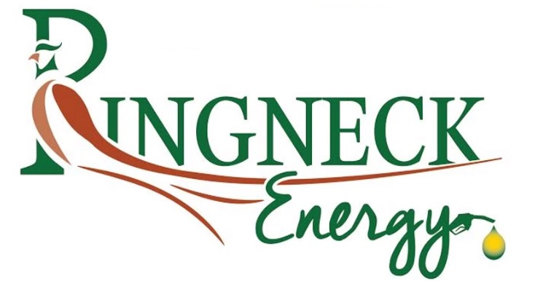
Onida, SD 57564 605-945-6900
Corn Discount Schedule
This schedule is subject to change without notice as market conditions warrant.
All discounts apply at time of delivery.
Updated 10/1/2024
Test Weight
2 cent per point from 53.9 to 52.0
3 cents per point from 51.9 to 50.0
4 cents per point from 49.9 to 48.0
Below 49.0 consult Commodities Manager, Subject to rejection

Moisture
4 cents per half point starting at 15.2 to 18.0
Moisture above 18.0 subject to rejection

Shrink
Nondeductible

Damage
1 cent each percent from 5.1 to 7.0
2 cents each percentage from 7.10 to 10.0
3 cents each percent from 10.1 to 20.0
Damage over 10% subject to rejection. . . Consult Commodities Manager.

Heat Damage
1 cent each 1/10 of a percent from .2% to 2.0%.
Over 2% subject to rejection. . . Consult Commodities Manager
FM
1 cent each point from 3.1 to 5.0
2 cents each point from 5.1 to 10.0
3 cents each point from 10.1 to 13.0
4 cents each point from above 13.1
Over 10% FM subject to rejection. . . Consult Commodities Manager

Other
- A maximum of 2% other Grains
- Corn that is found to be musty, sour, or containing commercial objectionable foreign odor (COFO) will be discounted 10 cents per bushel or may be rejected. Corn must meet all FDA and/or USDA fumigation requirements.
- Corn containing 2 or more live weevils or 10 or more other live grain storage insects per sample will be discounted 10 cents per bushel.
- Aflatoxin levels over 10ppb (parts per billion) will be rejected. Fumonisin levels over 5ppm (parts per million) will be rejected. Zearalenone levels over 100ppb will be rejected.
- Corn containing rodent or bird contamination, stones, glass or other commercially undesirable foreign material will be rejected.

